Pakistan Standards & Quality
Control Authority
Government of Pakistan
(Ministry of Science and Technology)

Tel: (92-21) 99261878
Website: www.psqca.com.pk
E-mail ID. dildarali_ansari@yahoo.com

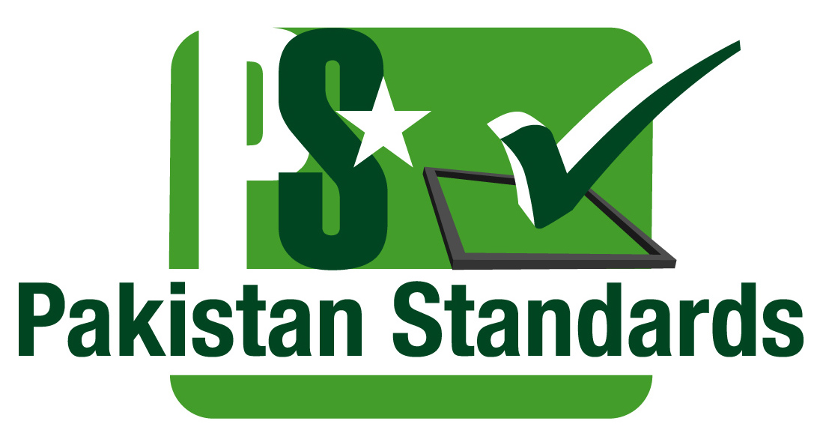

WTO TBT National Enquiry Point
Handling of Enquires (Local) on Technical Regulations, Standards and Conformity Assessment Procedures (2023)

S No. | Date | Email/Tel/Fax/Visit | From | Subject | Reason. | Reply  Date | Remarks
1 | 16-03-2023 | E-mail | A.D Civil Engineering | DIN EN-200 for Sanitary Tapware | The desired documents is price document also update to concern. | 16-03-2023 | OK
2 | 20-03-2023 | E-mail | A.D Civil Engineering | PS 4846-2007 Sanitary Tapware | The desired documents is price document also update to concern. | 20-03-2023 | OK
3
4
5
6
7
8
9
10
11
12
13
14
15
16
17
18
19
20
21
22

