Pakistan Standards & Quality
Control Authority
Government of Pakistan
(Ministry of Science and Technology)

Tel: (92-21) 99261878
Website: www.psqca.com.pk
E-mail ID. dildarali_ansari@yahoo.com

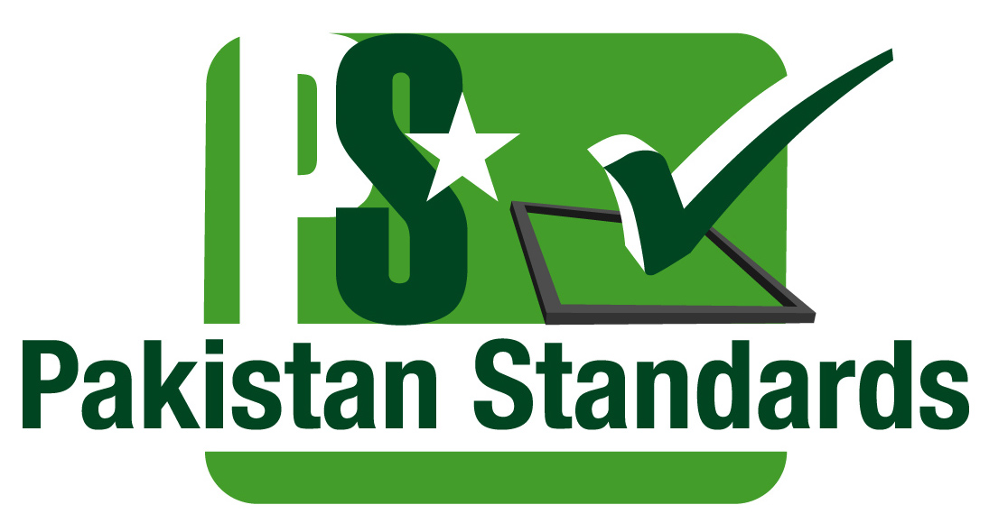

WTO TBT National Enquiry Point
Handling of Enquires (International) on Technical Regulations, Standards and Conformity Assessment Procedures (2023)
S No. | Date | Email/Tel/Fax/Visit | From | Subject | Reason | Reply  Date | Remarks
01
02

